Return Evaluation Comments

This unit has been in continuous operation for 3 years. 2 months. Vacuum may have failed about 2 months ago? Four tip links are damaged and rexolite is abraded by very rough vibration.

History from Data Sheet

Serial Num: 5C4-002-A

2015-08-14 Rob A’s board latest software & 12v jumper (rev a on board sn), Cooler vibration system up-date, Metal Flex bellows 347/304ss, vac gage removed, emi filter at hermetic d-sub up-date, Viton O-rings at SS base plate & borosilicate glass installed. Noise test completed very good results, vac & cryo working properly (data saved), HC PAX set-up & installed.
2015-08-18 Delivered to HC (1of2), installed on antenna 4J, 24+48v power supply up-dates added to Rim Box, Turbo & Cryo working properly, X pole poor performance, Y pole very good.
2015-08-24 Feed Test Report sent to HC (Elin).
2015-12-17 Control Board firmware up-dated to 3.12 at Hat Creek.
-------------------------------------------------------------------------------------------------
2018-06-01? Jon Richards had Mark move this Feed from Antenna 4J to 1E for testing reasons.
2018-08-01 HC Trip Rob S., Feed has a very loud Diaphragm pump but cooling to 67K/240watts, Vac 90k/16watts, ran out of time & parts, will replace the Diaphragm pump when we return in the fall to install new Feeds.
------------------------------------------------------------------------------------------------
2018-10-26 Feed delivered from Hat Creek by Jon Richards (3of4).
2018-10-(30-31) Removed Feed from transport box into Screen room, checked LNA’s condition, both poles have structure (data saves), biasing working properly
(x -.50_.08_1.20_40.9)(y -.50_.07_1.20_41.8), started pumpdown, Turbo stalled out at 12krpms, Diaphragm pump not running?, changed out Diaphragm pump & working properly, started pumpdown, Turbo stalled out at 26krpms, ran Diaphragm pump all night on hi-speed. Started pumpdown, got to 90krpms in 5min, Turbo working ok (90k/10w)(data saved), started cooldown but stopped once it looked correct (266K/301K/82watts)(data saved). Turned off Feed & set aside for inspection of tip.
2018-11-06 Removed Glass to inspect Pyramid & Tip, signs of some vibration, some Rexolite dust (stand-offs), all 4 sides of the Tip have damage (data saved), no signs of moisture, inside of enclosure dusty, Feed has been in continuous use sense 8/2015.

~

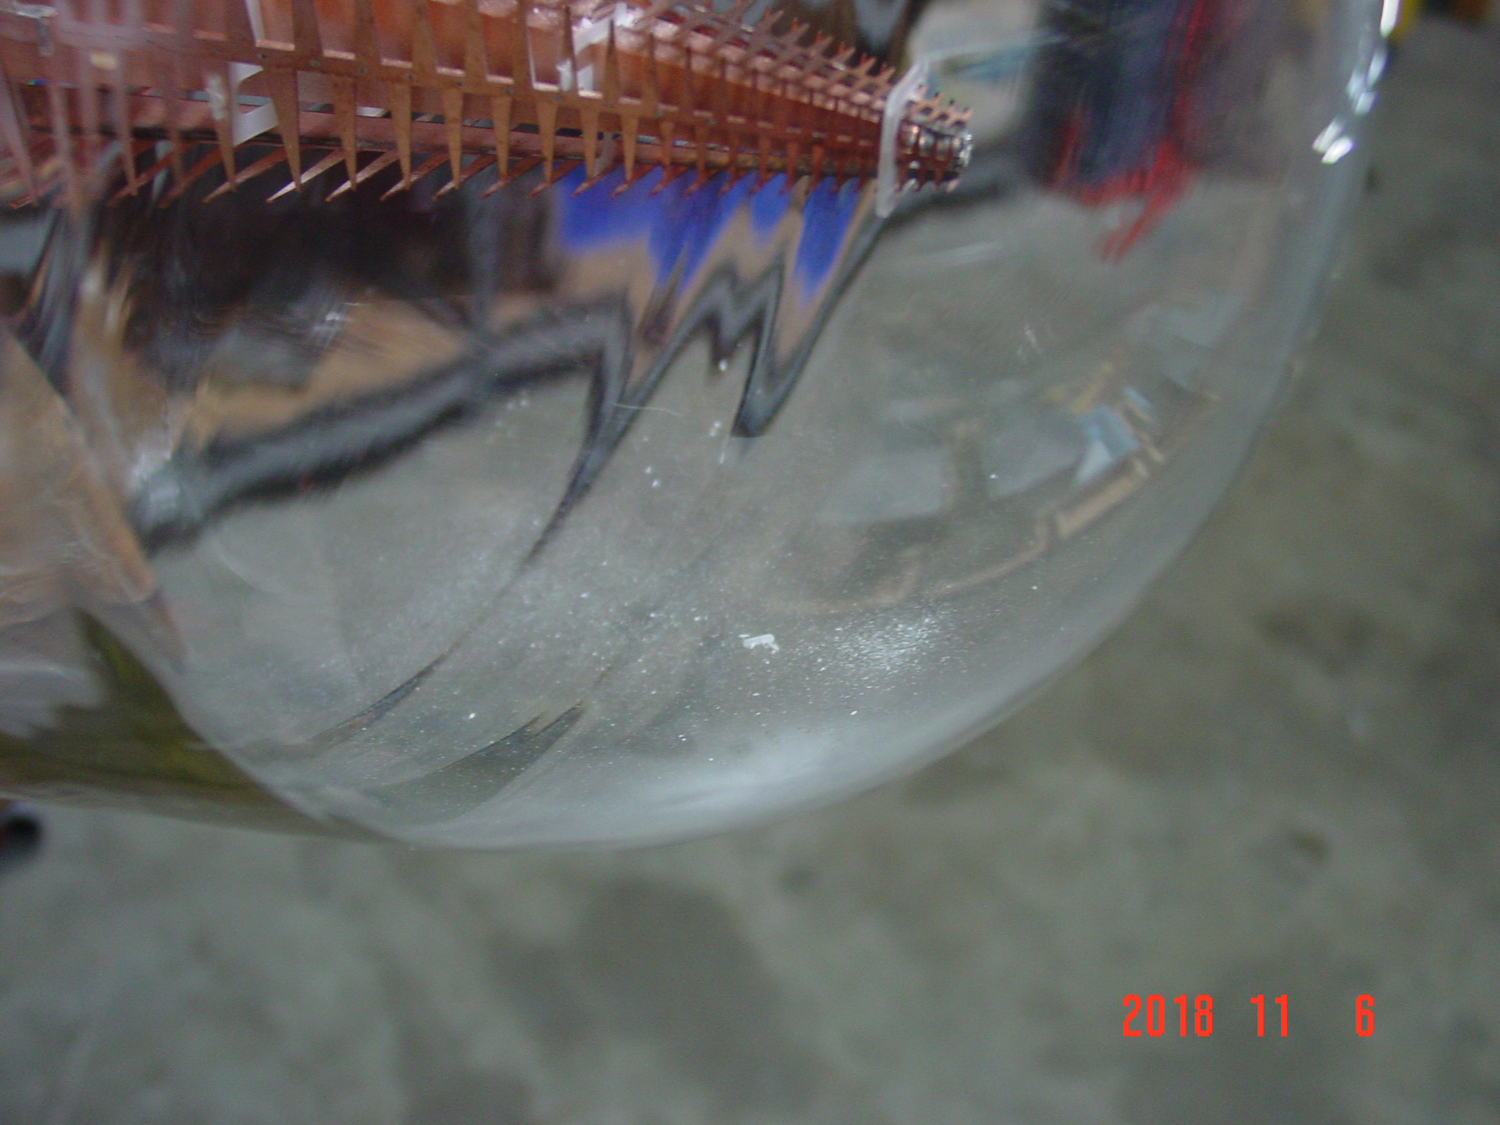  Rexolite dust on interior of glass | 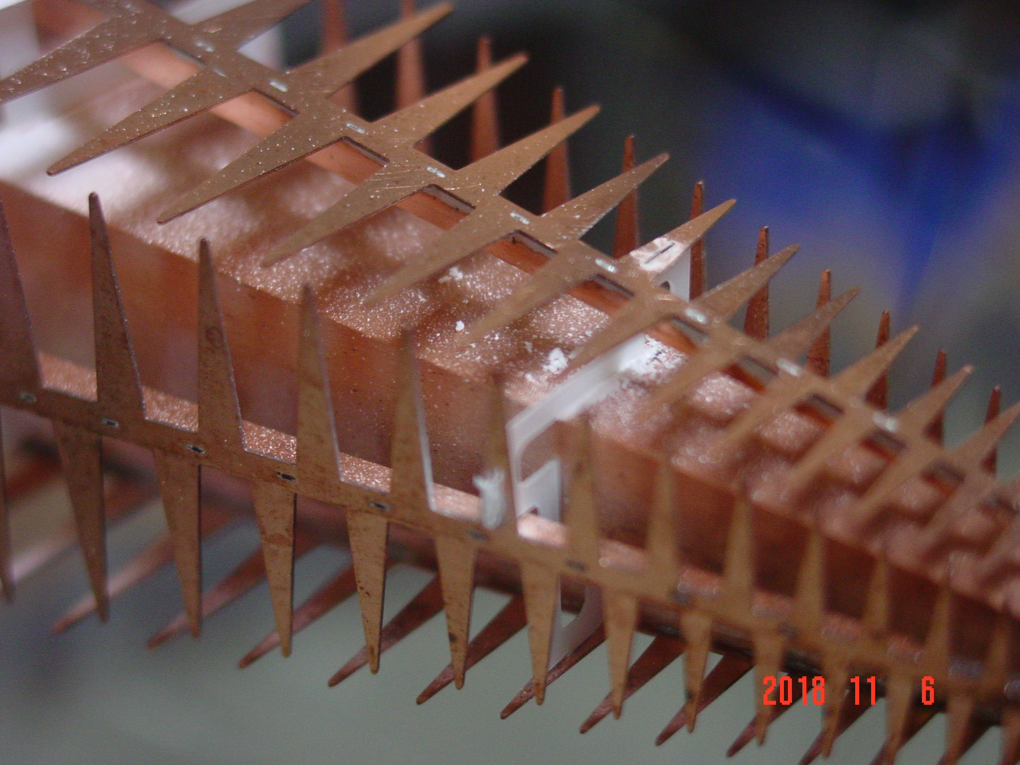  Quite a bit of dust on arms & pyramid.
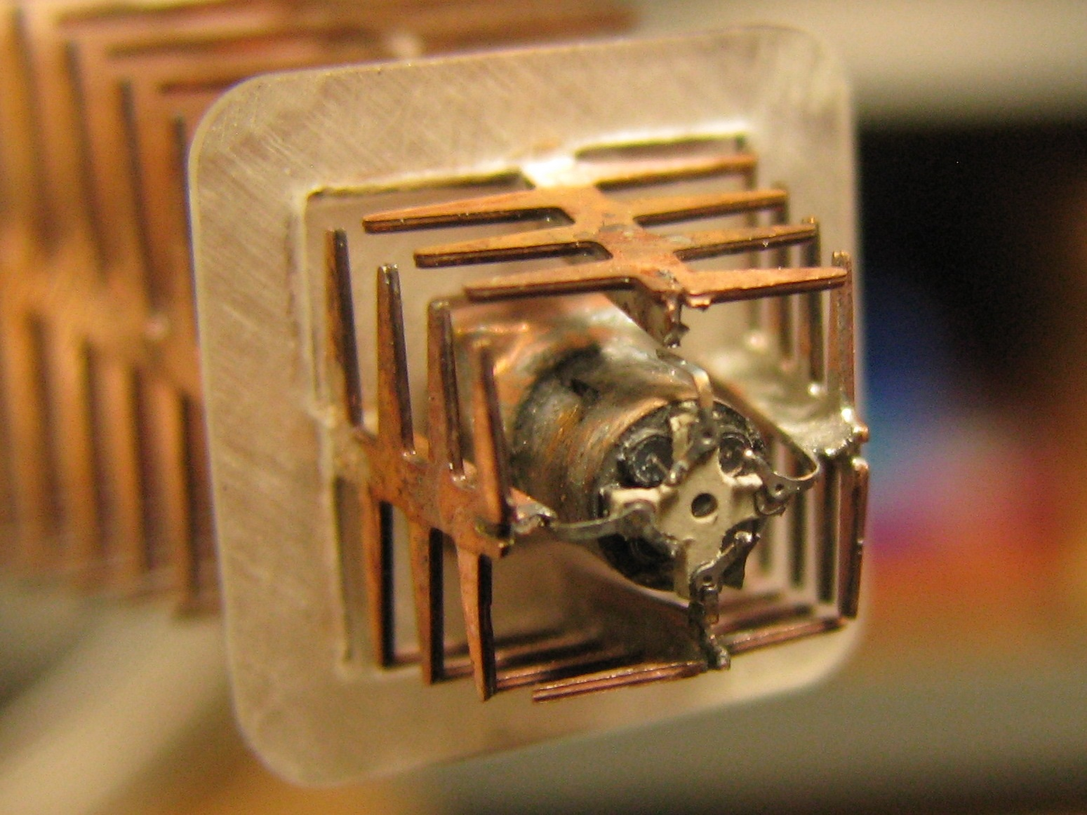 | 